Supporting Information

**Title:** Community ecology theory predicts the effects of agrochemical mixtures on aquatic biodiversity and ecosystem properties

**Authors:** Neal T. Halstead, Taegan A. McMahon, Steve A. Johnson, Thomas R. Raffel, John M. Romansic, Patrick W. Crumrine, Jason R. Rohr

**Supporting Methods**

*Mesocosm setup*

Water was aged for 24 hours before being seeded with algae and zooplankton collected from local ponds. On the day of algal and zooplankton inoculations, we also added four vertically oriented clay tiles (100 cm2) to the bottom of each tank to allow later quantification of periphyton growth, two of which were inaccessible to herbivores. We added 300 g of leaf litter (predominantly *Quercus virginiana*) to each mesocosm to provide refugia and detritus for vertebrates and macroinvertebrates. A pre-weighed packet of *Q. virginiana* leaf litter (5 g) enclosed in nylon screen was added to each tank to quantify leaf decomposition rates. Water was mixed weekly among the tanks during this three week establishment period to homogenize the algal and zooplankton communities before the addition of the agrochemical treatments. Immediately before the addition of the agrochemical treatments, each tank received two macrophyte (*Hydrilla verticillata* and *Utricularia macrorhiza*), four snail (*Melanoides tuberculata*, *Planorbella scalaris*, *P. trivolvis*, and *V. georgianus*), two tadpole (*Osteopilus septentrionalis* and *Rana sphenocephala*), and five macroarthropod species (*Anax junius*, *Belostoma flumineum*, Corixidae sp., *P. alleni*, and *Ranatra* sp.; initial abundances provided in Table S4). Macrophytes and *P. scalaris* generally established poorly in mesocosms and so were left out of most analyses.

Phytoplankton samples were collected weekly 10 cm below the water surface from the center of the tank. Periphyton was scraped from clay tiles biweekly and suspended in 50 mL dH2O. Chlorophyll a (measured as F0) and photosynthetic efficiency (QY) of phytoplankton and periphyton were measured using a handheld fluorometer (Z985 Cuvette AquaPen, Qubit Systems Inc., Kingston, Ontario, Canada) after algal samples were stored in darkness for 1 h. Zooplankton samples were collected biweekly from the entire water column by placing a PVC pipe (10 cm diameter, 60 cm height) upright in the center of each tank, capping the bottom, and pouring the water sample through 20 m Nitex mesh. Two zooplankton pipe samples were collected from each tank during each sampling period and the subsamples were combined and preserved in 70% ethanol. Zooplankton identity and abundance in each sample were determined by placing a 5 mL subsample in a zooplankton counting wheel (Wildlife Supply Company, Yulee, FL, USA) and examining it under a dissecting microscope. Temperature and light levels were quantified weekly by suspending data loggers (HOBO Pendant UA-002-64, Onset Computer Corporation, Bourne, MA, USA) 30 cm below the water surface for 30 minutes in each tank near midday. Dissolved oxygen, pH, and temperature were measured biweekly in each tank at both dawn and dusk. At the conclusion of the experiment, all tanks were drained through a kick net (800/900 m, 425-K11, Wildlife Supply Company, Yulee, FL, USA) to collect remaining organisms. All organisms were preserved in 70% ethanol.

*PERMANOVA analysis*

PERMANOVA is a non-parametric analogue to traditional ANOVA and MANOVA that allows for the use of non-Euclidean distance measures between samples (Anderson 2001a; McArdle & Anderson 2001; Anderson *et al.* 2008). We used a crossed design and a Type II sums of squares procedure to test for the main effects of each of the four agrochemicals, including a block effect, and all two-way interactions. The PERMANOVA routine calculates a pseudo-F statistic for each term in the model that is calculated identically to the traditional F statistic but has an unknown distribution when measures other than Euclidean distance are used. Significance of the pseudo-F statistic is therefore determined using appropriate permutation techniques (Anderson 2001b; Anderson & ter Braak 2003; Anderson *et al.* 2008). We used 9999 random permutations to generate P-values. Statistically, the responses to mixtures might be either additive or interactive. If a response to a mixture of agrochemicals was either more or less than anticipated by the combined main effects of that pair, the interaction term between the two agrochemicals would be significant. Thus, a significant interaction term may indicate that a given community exposed to a mixture treatment was either more or less similar to the control treatment than expected. When interaction terms involving spatial block were not significant, they were pooled with the residual variation in the model.

Like traditional ANOVA, PERMANOVA assumes that there is homogeneity of variance among treatments. We tested for differences in multivariate homogeneity of variance, using the PERMDISP routine in PRIMER-E (Anderson *et al.* 2008). We tested for homogeneity of the Bray-Curtis dissimilarity of each replicate from the treatment spatial median by generating an F-statistic and comparing that to the known distribution of the F-statistic.

Community-level analysis was restricted to all abundance measurements at the end of the experiment. We used Bray-Curtis similarity as the distance measure for the PERMANOVA and dbRDA analyses of the full community. Principle coordinates analysis was also performed as an unconstrained ordination to confirm that the dbRDA analysis was capturing the salient patterns in the data (Fig. S1). Analyses were also performed using Hellinger distance to determine if the effects of agrochemicals on the relative abundances of species were the same as those on absolute abundances; all patterns were similar, so we restricted the reported results to those on absolute abundance (Bray-Curtis similarity). When examining the responses of individual taxa to agrochemicals, we used the same crossed design, PERMANOVA analysis as for the full community, but on the Euclidean distance between tanks calculated separately for each taxon, rendering these analyses equivalent to traditional univariate ANOVAs (Anderson *et al.* 2008). Individual algal and zooplankton responses over time were analyzed by including a time term to the above crossed design to account for repeated measures.

**Supporting Figure Legends**

Figure S1. Principle coordinates analysis (PCO) of community-level responses to agrochemical treatments showing A) vector overlays of predictor variables and B) vector overlays of species responses. Species abbreviations are *Cal*. = calanoid copepods, *Cer. =* *Ceriodaphnia* sp., *Cor.* = Corixidae sp., *Cyc*. = cyclopoid copepods, *Dia. =* *Diaphanosoma* sp., *Lit.* = percent leaf litter mass remaining, *Ost. = Osteopilus septentrionalis*, *Phy*. = phytoplankton F0, *Pla. = Planorbella trivolvis*, *Pro. = Procambarus alleni*.

Figure S2. Responses of algae to agrochemicals. Responses of phytoplankton chlorophyll *a* (means ± SEM) to fertilizer-only (solid black lines), biocide-only (A: fungicide; B: insecticide; C: herbicide; dashed lines), and respective pairwise mixtures (dotted lines) over time relative to detrended control treatments (line at zero). N=8 for all treatments, except mixture treatments where n = 4. Responses of periphyton chlorophyll *a* (means ± SEM) to fungicide (D) and herbicide (E) presence or absence.

Figure S3. Responses of zooplankton (means ± SEM) to fertilizer-only (solid black lines), biocide-only (A-B: fungicide; C-D: insecticide; dashed lines), and respective pairwise mixtures (dotted lines) over time relative to detrended control treatments (line at zero). N=8 for all treatments, except mixture treatments where n = 4.

Figure S4. Interaction plots between fertilizer and biocides (A-B: fungicide; C-D: herbicide) for *Viviparus georgianus* and *Planorbella trivolvis* (means ± SEM). N=8 for all treatments, except mixture treatments where n = 4.

Figure S1.



Figure S2.

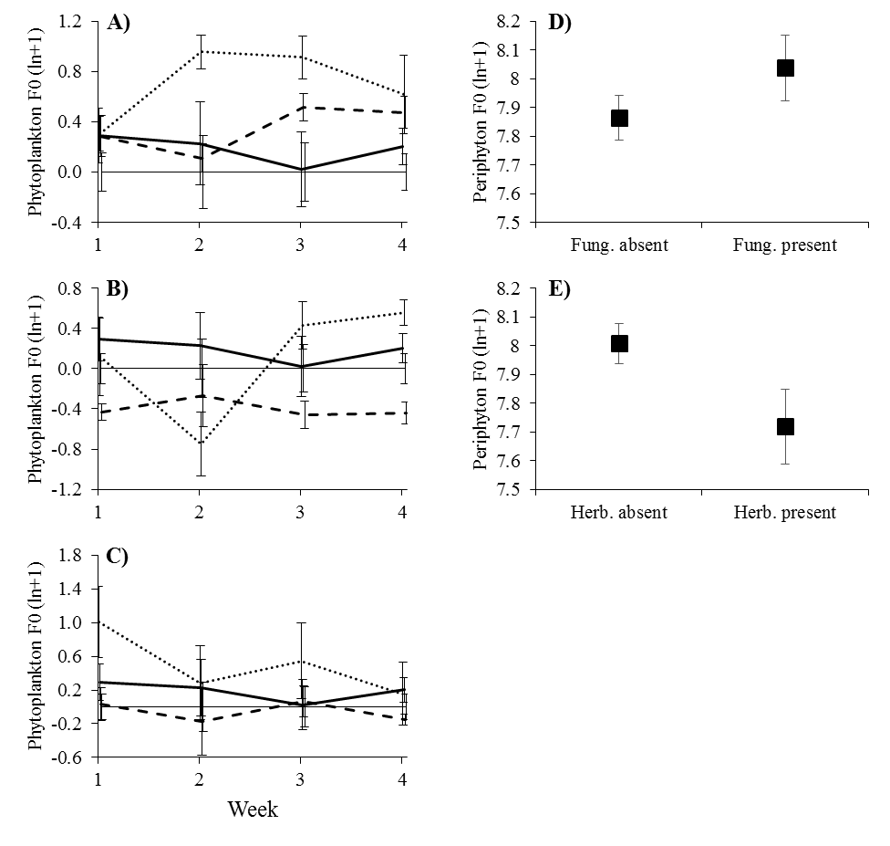

Figure S3.

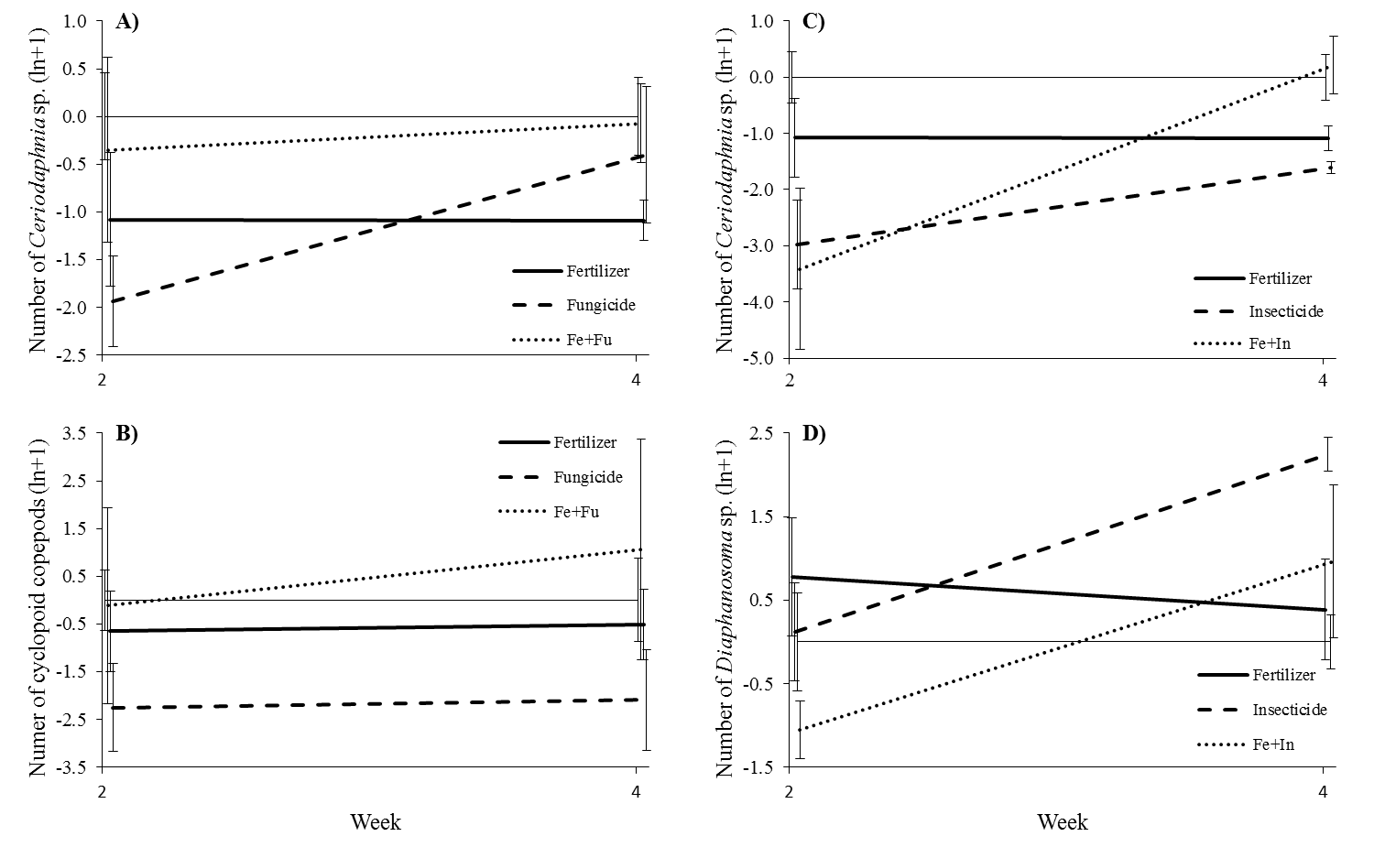

Figure S4.

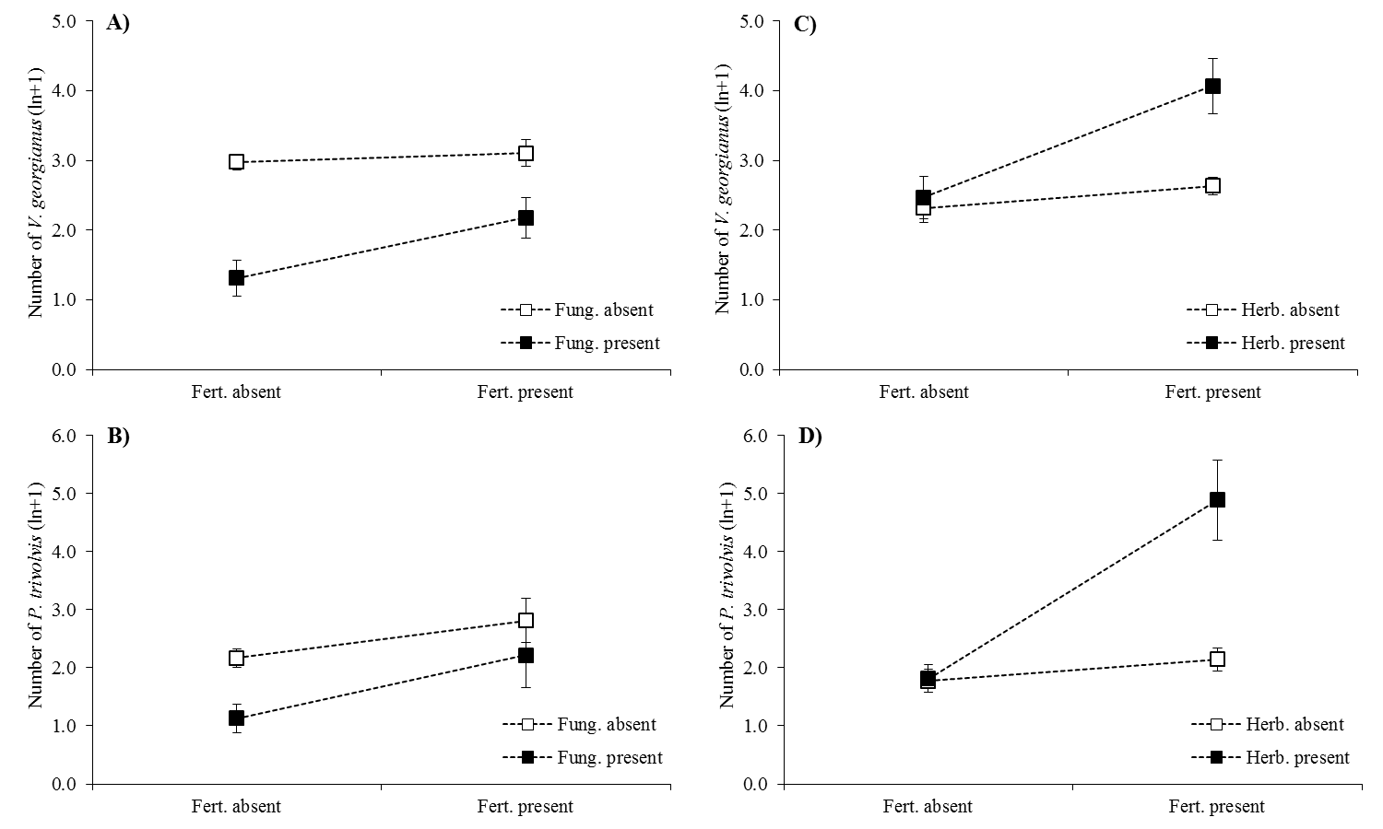

**Supporting Tables**

Table S1. Initial abundances

|  |  |  |
| --- | --- | --- |
| Species | Stage | Quantity |
| Amphibians |  |  |
| *Osteopilus septentrionalis* | larvae | 25 |
| *Rana sphenocephala* | larvae | 10 |
|  |  |  |
| Gastropods |  |  |
| *Melanoides tuberculata* | adults | 20 |
| *Planorbella scalaris* | adults | 10 |
| *Planorbella trivolvis* | adults | 9 |
| *Viviparus georgianus* | adults | 10 |
|  |  |  |
| Macroarthropods |  |  |
| *Anax junius* | nymphs | 2 |
| *Belostoma flumineum* | adults | 5 |
| Corixidae sp. | adults | 10 |
| *Procambarus alleni* | juveniles | 3 |
| *Ranatra* sp. | adults | 3 |
|  |  |  |
| Macrophtes |  |  |
| *Hydrilla verticillata* | - | 250 g |
| *Utricularia macrorhiza* | - | 250 g |

Table S2. PERMANOVA analyses of individual species responses to agrochemical mixtures. Values given are F statistics followed by permutation-derived P-values in parentheses. All terms in the model have numerator df=1, except spatial block and any interaction term involving it where numerator df=3. Denominator degrees of freedom for the test of each response variable are indicated by superscripts as follows: *=63, †=127, ‡=255.

|  |  |  |  |  |  |  |  |  |  |  |  |  |  |  |  |  |  |  |  |  |  |  |
| --- | --- | --- | --- | --- | --- | --- | --- | --- | --- | --- | --- | --- | --- | --- | --- | --- | --- | --- | --- | --- | --- | --- |
| Response variable | Fe | Fu | He | In | Block | Fe*Fu | Fe*He | Fe*In | Fu*He | Fu*In | He*In | Time | Ti*Fe | Ti*Fu | Ti*He | Ti*In | Ti*Fe*Fu | Ti*Fe*He | Ti*Fe*In | Ti* Fu*He | Ti*Fu*In | Ti*He*In |
| *Rana sphenocephala*\* | 3.116 (0.0774) | **7.584**  **(0.0076)** | **4.368 (0.0434)** | 0.001 (0.9701) | **3.963 (0.0118)** | 2.368 (0.1301) | 0.046 (0.8352) | 2.019 (0.1604) | 0.811 (0.3821) | 0.028 (0.8644) | 0.613 (0.4411) |  |  |  |  |  |  |  |  |  |  |  |
| *Osteopilus septentrionalis\** | 0.101 (0.7485) | **90.131 (0.0001)** | 1.369 (0.2464) | 0.395 (0.5379) | **2.734 (0.0537)** | 1.532 (0.2252) | 0.789 (0.3858) | 0.418 (0.5295) | 0.152 (0.6947) | 0.275 (0.6060) | 0.179 (0.6779) |  |  |  |  |  |  |  |  |  |  |  |
| *Anax junius\** | 1.148 (0.2889) | 0.013 (0.9107) | **5.660 (0.0215)** | 0.263 (0.6128) | **6.836 (0.0008)** | 0.000 (1.0000) | 3.935 (0.0518) | 0.050 (0.8243) | 0.291 (0.5918) | 1.871 (0.1846) | 3.890 (0.0548) |  |  |  |  |  |  |  |  |  |  |  |
| *Belostoma flumineum\** | 0.032 (0.8652) | 0.113 (0.7362) | 0.509 (0.4791) | 0.383 (0.5358) | 1.549 (0.2107) | 0.571 (0.4524) | 0.412 (0.5304) | 0.000 (1.0000) | 0.003 (0.9590) | 0.908 (0.3397) | 3.030 (0.0867) |  |  |  |  |  |  |  |  |  |  |  |
| *Ranatra* sp.* | 0.018 (0.8988) | 0.128 (0.7244) | 0.002 (0.9716) | 2.851 (0.1026) | 1.147 (0.3423) | 0.001 (0.9700) | 0.062 (0.7999) | 1.180 (0.2878) | 0.016 (0.9010) | 2.124 (0.1452) | 0.166 (0.5026) |  |  |  |  |  |  |  |  |  |  |  |
| *Procambarus alleni\** | **26.706 (0.0001)** | 3.116 (0.0831) | **20.022 (0.0001)** | 2.787 (0.1012) | 0.823 (0.5008) | **13.268 (0.0009)** | **12.094 (0.0013)** | 0.396 (0.5296) | 0.027 (0.8697) | 0.027 (0.8706) | 0.216 (0.6407) |  |  |  |  |  |  |  |  |  |  |  |
| Corixidae sp.* | 1.202 (0.2696) | 3.379 (0.0708) | 0.674 (0.4137) | 0.442 (0.5050) | 1.094 (0.3539) | 0.070 (0.7880) | 0.052 (0.8208) | 0.010 (0.9183) | 0.613 (0.4349) | 0.204 (0.6542) | 0.141 (0.7028) |  |  |  |  |  |  |  |  |  |  |  |
| *Planorbella trivolvis\** | **10.052 (0.0023)** | **8.196 (0.0067)** | **4.979 (0.0301)** | 0.852 (0.3553) | 0.070 (0.9764) | **7.047 (0.0117)** | **20.964 (0.0003)** | 2.866 (0.0974) | 0.592 (0.4407) | 0.438 (0.5115) | 0.747 (0.3972) |  |  |  |  |  |  |  |  |  |  |  |
| *Planorbella scalaris\** | 2.777 (0.0975) | **6.242 (0.0132)** | 0.106 (0.7529) | 3.881 (0.0536) | 0.490 (0.7087) | 1.710 (0.1976) | 0.282 (0.5982) | 1.710 (0.1943) | 0.120 (0.7291) | 2.708 (0.1057) | 1.475 (0.2288) |  |  |  |  |  |  |  |  |  |  |  |
| *Planorbella* (total)* | **6.038 (0.0184)** | **11.233 (0.0018)** | **5.325 (0.0255)** | 0.098 (0.7539) | 0.110 (0.9527) | **7.575 (0.0081)** | **16.972 (0.0002)** | 3.433 (0.0709) | 0.349 (0.5502) | 0.951 (0.3379) | 0.538 (0.4609) |  |  |  |  |  |  |  |  |  |  |  |
| *Viviparus georgianus\** | 3.873 (0.0569) | **58.216 (0.0001)** | 0.936 (0.3413) | 2.270 (0.1396) | 1.031 (0.3883) | **7.037 (0.0114)** | 2.905 (0.0960) | 0.005 (0.9442) | 0.469 (0.4988) | **7.537 (0.0077)** | 0.000 (0.9843) |  |  |  |  |  |  |  |  |  |  |  |
| *Melanoides tuberculata\** | 0.119 (0.7355) | **7.437 (0.0074)** | 2.495 (0.1227) | 2.930 (0.0892) | 0.893 (0.4621) | 0.390 (0.5385) | 0.526 (0.4670) | 0.276 (0.5920) | 1.906 (0.1715) | 1.577 (0.2161) | 1.981 (0.1632) |  |  |  |  |  |  |  |  |  |  |  |
| Leaf litter* | 0.097 (0.7589) | **12.264 (0.0013)** | 0.406 (0.5331) | 0.029 (0.8691) | 0.260 (0.8524) | 0.144 (0.7151) | 0.380 (0.5389) | 0.251 (0.6237) | **7.317 (0.0093)** | 2.121 (0.1482) | 2.100 (0.1552) |  |  |  |  |  |  |  |  |  |  |  |
| Copepod nauplii† | 2.236 (0.1354) | 0.502 (0.4812) | 0.431 (0.4952) | 2.258 (0.1366) | 1.596 (0.2046) | 0.736 (0.3927) | 0.201 (0.6514) | 0.330 (0.5664) | 0.038 (0.8408) | 1.684 (0.1913) | 1.196 (0.2772) | 1.019 (0.4049) | 0.045 (0.8306) | 2.600 (0.1136) | **7.948 (0.0059)** | 0.438 (0.5166) | 0.595 (0.4411) | **3.888 (0.0501)** | **4.921 (0.0311)** | 0.366 (0.5454) | 0.991 (0.3219) | 2.289 (0.1357) |
| Calanoidea spp.† | 0.108 (0.7520) | **51.004 (0.0001)** | 0.640 (0.4283) | 1.614 (0.2066) | 2.012 (0.1197) | 2.612 (0.1066) | 0.290 (0.5942) | 3.224 (0.0737) | 0.174 (0.7104) | 3.250 (0.0776) | **4.889 (0.0276)** | 0.156 (0.6779) | 0.002 (0.9702) | 0.718 (0.4033) | 1.329 (0.2509) | **7.316 (0.0091)** | **5.332 (0.0224)** | 0.002 (0.9706) | 0.243 (0.6238) | **4.2987 (0.0401)** | **7.0331 (0.0112)** | 0.007 (0.9341) |
| Cyclopoidea spp.† | 0.555 (0.4507) | 0.020 (0.8934) | 0.025 (0.8810) | 1.900 (0.1746) | 1.053 (0.3614) | **6.059 (0.0174)** | 0.287 (0.5900) | 0.015 (0.8994) | 0.902 (0.3537) | 1.307 (0.2601) | 0.135 (0.7125) | **4.183 (0.0430)** | 2.409 (0.1181) | 0.210 (0.6401) | **5.446 (0.0236)** | 0.268 (0.6007) | pooled | pooled | pooled | pooled | pooled | pooled |
| *Ceriodaphnia* sp.† | 0.001 (1.0000) | 0.160 (0.6831) | 0.002 (0.9643) | **19.379 (0.0001)** | **4.486 (0.0067)** | **6.952 (0.0107)** | 2.070 (0.1470) | **5.276 (0.0237)** | **5.017 (0.0291)** | 1.607 (0.2127) | **6.429 (0.0145)** | 0.308 (0.5797) | 0.918 (0.3416) | 0.222 (0.6468) | 0.038 (0.8481) | **5.099 (0.0281)** | pooled | pooled | pooled | 0.146 (0.7264) | pooled | pooled |
| *Diaphanosoma* sp.† | 0.797 (0.3733) | 2.600 (0.0998) | 0.455 (0.4926) | 0.445 (0.4939) | **2.797 (0.0422)** | 1.260 (0.2678) | 1.790 (0.1864) | **4.940 (0.0296)** | 1.373 (0.2483) | 0.193 (0.6576) | **7.768 (0.0075)** | **11.256 (0.0013)** | 0.413 (0.5233) | 2.823 (0.0924) | 2.494 (0.1165) | **20.609 (0.0001)** | pooled | pooled | pooled | pooled | pooled | pooled |
| Periphyton F(0) - accessible† | 2.707 (0.1046) | **4.832 (0.0303)** | **5.390 (0.0201)** | 2.760 (0.0982) | **8.582 (0.0001)** | **4.297 (0.0410)** | 0.089 (0.7626) | **6.589 (0.0114)** | 1.541 (0.2708) | **13.097 (0.0005)** | 3.574 (0.0623) | 4.695 (0.1129) | 1.067 (0.3003) | 0.380 (0.5366) | 0.029 (0.8616) | 0.427 (0.5156) | pooled | pooled | pooled | pooled | pooled | pooled |
| Periphyton F(0) - inaccessible† | 2.922 (0.0926) | **5.713 (0.0172)** | 0.010 (0.9235) | 0.722 (0.4049) | **4.745 (0.0045)** | 0.450 (0.5063) | 0.532 (0.4662) | 1.159 (0.2846) | **4.333 (0.0389)** | 0.769 (0.3791) | 0.104 (0.7491) | 1.512 (0.2200) | 0.005 (0.9467) | 0.535 (0.4661) | 1.150 (0.2879) | 0.188 (0.6681) | pooled | **9.067 (0.0031)** | pooled | pooled | pooled | pooled |
| Phytoplankton F(0)‡ | 6.107 (0.0701) | **32.293 (0.0001)** | **8.805 (0.0039)** | 1.541 (0.3008) | **3.089 (0.0264)** | 0.561 (0.4526) | 1.877 (0.1730) | 1.239 (0.3560) | 0.100 (0.7542) | 0.717 (0.5220) | 2.651 (0.1063) | **17.202 (0.0001)** | 0.301 (0.8290) | 1.135 (0.3456) | 1.061 (0.3676) | 1.989 (0.1100) | pooled | **3.261 (0.0238)** | pooled | pooled | pooled | pooled |

Table S3. Pairwise tests of Bray-Curtis similarity between treatments (absolute abundance).

|  |  |  |  |
| --- | --- | --- | --- |
| Treatments | | t | P(perm) |
| Water | Solvent | 0.9755 | 0.4591 |
| Fe 1x | Fe 2x | 1.0051 | 0.4158 |
| Fu 1x | Fu 2x | 1.3442 | 0.1813 |
| He 1x | He 2x | 1.5113 | 0.1121 |
| In 1x | In 2x | 1.3875 | 0.1960 |
| Control | Fertilizer | 1.1716 | 0.3404 |
| Control | Fungicide | 2.8284 | **0.0267** |
| Control | Herbicide | 1.0455 | 0.3632 |
| Control | Insecticide | 1.9938 | **0.0493** |
| Control | Fe+Fu | 1.4539 | 0.1033 |
| Control | Fe+He | 2.0776 | 0.0754 |
| Control | Fe+In | 0.9439 | 0.5937 |
| Control | Fu+He | 2.8767 | **0.0310** |
| Control | Fu+In | 2.9436 | **0.0291** |
| Control | He+In | 1.5729 | 0.1125 |
| Fertilizer | Fungicide | 2.3270 | 0.0541 |
| Fertilizer | Herbicide | 1.2187 | 0.2759 |
| Fertilizer | Insecticide | 1.6022 | 0.0742 |
| Fungicide | Herbicide | 2.9416 | **0.0304** |
| Fungicide | Insecticide | 3.5199 | **0.0302** |
| Herbicide | Insecticide | 1.4497 | 0.1159 |
| Fertilizer | Fe+Fu | 1.8004 | **0.0488** |
| Fertilizer | Fe+He | 1.9096 | **0.0499** |
| Fertilizer | Fe+In | 1.2363 | 0.2621 |
| Fungicide | Fe+Fu | 1.5065 | 0.1107 |
| Fungicide | Fu+He | 0.9738 | 0.4555 |
| Fungicide | Fu+In | 2.1907 | 0.0672 |
| Herbicide | Fe+He | 1.4661 | 0.1246 |
| Herbicide | Fu+He | 2.5781 | **0.0332** |
| Herbicide | He+In | 0.9531 | 0.4470 |
| Insecticide | Fe+In | 1.1392 | 0.2937 |
| Insecticide | Fu+In | 2.2847 | **0.0302** |
| Insecticide | He+In | 1.1310 | 0.2916 |

Table S4. Results of a path model conducted in the package Lavaan in R revealing the relationships among agrochemical mixtures, algal herbivores and competitors, algae, and ecosystem properties.

|  |  |  |  |  |  |  |
| --- | --- | --- | --- | --- | --- | --- |
| Regression | | Estimate | Std.err | Standardized estimate | Z-value | P(>|z|) |
| Abundance of phytoplankton herbivores and competitors~ | | | | |  |  |
|  | Spatial block | -0.234 | 0.080 | -0.264 | -2.933 | **0.003** |
|  | Fertilizer (Fe) | 0.135 | 0.150 | 0.126 | 0.898 | 0.369 |
|  | Herbicide (He) | 0.191 | 0.103 | 0.179 | 1.858 | 0.063 |
|  | Fungicide (Fu) | -0.010 | 0.150 | -0.010 | -0.069 | 0.945 |
|  | Insecticide (In) | 0.532 | 0.150 | 0.497 | 3.550 | **<0.001** |
|  | Fe*Fu | 0.332 | 0.124 | 0.335 | 2.682 | **0.007** |
|  | Fe*In | 0.286 | 0.124 | 0.288 | 2.311 | **0.021** |
|  | Fu*In | 0.475 | 0.124 | 0.478 | 3.833 | **<0.001** |
|  |  |  |  |  |  |  |
| Abundance of periphyton herbivores~ | | |  |  |  |  |
|  | Crayfish biomass | -1.077 | 0.240 | -0.365 | -4.478 | **<0.001** |
|  | Block | -0.096 | 0.051 | -0.108 | -1.890 | 0.059 |
|  | Fertilizer | 0.366 | 0.145 | 0.342 | 2.523 | **0.012** |
|  | Herbicide | 0.094 | 0.112 | 0.088 | 0.838 | 0.402 |
|  | Fungicide | -0.520 | 0.124 | -0.485 | -4.189 | **<0.001** |
|  | Insecticide | 0.240 | 0.099 | 0.224 | 2.425 | **0.015** |
|  | Fe*He | 0.224 | 0.092 | 0.226 | 2.442 | **0.015** |
|  | Fe*Fu | 0.189 | 0.095 | 0.190 | 1.981 | **0.048** |
|  | Fe*In | 0.117 | 0.082 | 0.118 | 1.423 | 0.155 |
|  | He*Fu | 0.094 | 0.083 | 0.095 | 1.128 | 0.259 |
|  | He*In | 0.177 | 0.082 | 0.179 | 2.157 | **0.031** |
|  |  |  |  |  |  |  |
| Phytoplankton abundance~ | |  |  |  |  |  |
|  | Phytoplankton herbivores | -0.366 | 0.115 | -0.366 | -3.185 | **0.001** |
|  | Block | -0.223 | 0.096 | -0.251 | -2.324 | **0.020** |
|  | Fertilizer | 0.195 | 0.135 | 0.182 | 1.442 | 0.149 |
|  | Herbicide | 0.091 | 0.137 | 0.085 | 0.660 | 0.509 |
|  | Insecticide | -0.259 | 0.118 | -0.242 | -2.200 | **0.028** |
|  | Fe*He | 0.257 | 0.132 | 0.258 | 1.938 | 0.053 |
|  |  |  |  |  |  |  |
| Periphyton abundance~ | |  |  |  |  |  |
|  | Periphyton herbivores | -0.364 | 0.116 | -0.364 | -3.137 | **0.002** |
|  | Fertilizer | 0.046 | 0.143 | 0.043 | 0.325 | 0.745 |
|  | Herbicide | -0.137 | 0.138 | -0.128 | -0.994 | 0.320 |
|  | Insecticide | 0.266 | 0.162 | 0.248 | 1.638 | 0.101 |
|  | Fe*In | 0.234 | 0.136 | 0.235 | 1.715 | 0.086 |
|  | He*In | 0.245 | 0.137 | 0.247 | 1.792 | 0.073 |
|  |  |  |  |  |  |  |
| Ecosystem properties axis 1 (Dissolved oxygen, pH, decomposition)~ | | | | | |  |
|  | Phytoplankton | -0.183 | 0.082 | -0.193 | -2.219 | **0.026** |
|  | Periphyton | -0.145 | 0.084 | -0.152 | -1.712 | 0.087 |
|  | Fungicide | -0.618 | 0.092 | -0.608 | -6.716 | **<0.001** |
|  |  |  |  |  |  |  |
| Ecosystem properties axis 2 (Light, temperature)~ | | | |  |  |  |
|  | Phytoplankton | -0.145 | 0.067 | -0.145 | -2.173 | **0.030** |
|  | Block | 0.722 | 0.059 | 0.814 | 12.280 | **<0.001** |

Table S5. Parameters used for calculation of peak estimated environmental concentrations (EEC).

|  |  |  |  |
| --- | --- | --- | --- |
| GENEEC Parameter | Atrazine | Malathion | Chlorothalonil |
| Trade name | Aatrex | Fyfanon ULV | Bravo Weather Stik |
| Crop | Corn | Mosquito control | Potato |
| Rate (pounds of active ingredients/acre taken from specimen label) | 2 | 6 | 1.25 |
| Number of applications | 1 | 1 | 9 |
| Times between applications | - | - | 5 |
| koc (use lowest) | 100b | 1248c | 1380b |
| Soil half-life (days) | 300c | 6d | 90b |
| Wetted application? | No | No | Yes |
| Application method | Ground spraya | Ground spraya | Ground spraya |
| Nozzle height (in.) | 20-50: EFEDa | 20-50: EFEDa | 20-50: EFEDa |
| Spray Quality | fine: EFEDa | fine: EFEDa | fine: EFEDa |
| No spray zone (feet) | 0 | 0 | 0 |
| Depth of incorporation (0-6 inches) | 0 | 0 | 0 |
| Solubility (mg/L) | 33 | 130b | 0.6b |
| Aquatic half-life (days) - use longest | 742d | - | 8.8d |
| Hydrolysis half-life (days) - use longest | - | 147d | 38d |
| Photolysis half-life (days) - usually the longest number | 335d | - | - |
| Peak EEC (g/L) | 102 | 101 | 164 |
| a Program default value |  |  |  |
| b http://extoxnet.orst.edu/ |  |  |  |
| c USDA |  |  |  |
| d Spectrum Laboratories Inc., http://www.speclab.com/ | | |  |

**Supporting References**

1.

Anderson, M.J. (2001a). A new method for non-parametric multivariate analysis of variance. *Austral Ecol*., 32–46.

2.

Anderson, M.J. (2001b). Permutation tests for univariate or multivariate analysis of variance and regression. *Can. J. Fish. Aquat. Sci*., 58, 626–639.

3.

Anderson, M.J. & ter Braak, C.J.F. (2003). Permutation tests for multi-factorial analysis of variance. *J. Stat. Comput. Simul*., 73, 85–113.

4.

Anderson, M.J., Clarke, K.R. & Gorley, R.N. (2008). PERMANOVA+ for PRIMER: Guide to Software and Statistical Methods.

5.

McArdle, B.H. & Anderson, M.J. (2001). Fitting multivariate models to community data: a comment on distance-based redundancy analysis. *Ecology*, 82, 290–297.