Supplemental Methods

Tadpole Mouthpart Dissections
We viewed each tadpole under a stereomicroscope and dissected the oral disc from B. terrestris and H. cinerea tadpoles using a scalpel. Because tadpoles of these species have keratinized mouthparts and a papillated margins surrounding their mouths, we were easily able to remove the target tissues for our qPCR analyses. Gastrophryne carolinensis tadpoles, however, lack keratinized mouthparts and oral papillae, so we did not have any landmarks for our dissections. Thus, to standardize the relative amount of tissue that we dissected among individuals, we made a transverse cut at the level of the eyes to remove the rostrum of the tadpole from the rest of the head and body. To ensure that we did not accidentally contaminate our samples, we used 10% bleach to sterilize the floor of the dissecting scope between each dissection and dipped our dissecting equipment sequentially in 10% bleach, 1% Novaqua® (which neutralizes bleach), and deionized water.

DNA Extractions and qPCR analyses
Our DNA extractions and qPCR analyses followed the methods of (Boyle et al. 2004) and modified by (Hyatt et al. 2007). Test samples were run singly instead of triplicate to control costs, as recommended by (Kriger, Hero & Ashton 2006). We added TaqMan® Exogenous Internal Positive Control (Exo IPC) Reagents (Applied Biosystems, Foster City, CA) to every reaction well to assess inhibition of the PCR reaction (Hyatt et al. 2007). The Exo IPC system uses a standardized concentration of an artificial DNA sequence that is added to each reaction well with its own set of primers and a separate fluorescent probe. The strength of this reaction is used to assess overall reaction inhibition. Extractions were diluted 1:100 and processed in an Applied Biosystems Step One Real-time PCR system. None of our samples were inhibited and thus did not require any further dilution. We considered infection intensity as the number of Bd zoospore equivalents per sample. Zoospore equivalents were calculated by multiplying the genome equivalent values generated by the qPCR assay by 800, which accounts for the fact that the DNA from the mouthparts was diluted 800-fold during extraction and qPCR preparation. To minimize the chance of detecting a false positive, we re-ran any sample with a zoospore equivalent ≤ 10. We considered a sample Bd positive when zoospore equivalents were ≥ 1 (Vredenburg et al. 2010).

Boyle, D.G., Boyle, D.B., Olsen, V., Morgan, J.A.T. & Hyatt, A.D. (2004) Rapid quantitative detection of chytridiomycosis (Batrachochytrium dendrobatidis) in amphibian samples using real-time Taqman PCR assay. Diseases of Aquatic Organisms, 60, 141-148.
Hyatt, A.D., Boyle, D.G., Olsen, V., Boyle, D.B., Berger, L., Obendorf, D., Dalton, A., Kriger, K., Hero, J.M., Hines, H., Phillott, R., Campbell, R., Marantelli, G., Gleason, F. & Colling, A. (2007) Diagnostic assays and sampling protocols for the detection of Batrachochytrium dendrobatidis. Diseases of Aquatic Organisms, 73, 175-192.
Kriger, K.M., Hero, J.M. & Ashton, K.J. (2006) Cost efficiency in the detection of chytridiomycosis using PCR assay. Diseases of Aquatic Organisms, 71, 149-154.
Vredenburg, V.T., Knapp, R.A., Tunstall, T.S. & Briggs, C.J. (2010) Dynamics of an emerging disease drive large-scale amphibian population extinctions. Proceedings of the National Academy of Sciences of the United States of America, 107, 9689-9694.

Table S1. Fully factorial design to test the effects of tadpole diversity (Bufo terrestris, Gastrophryne carolinensis and Hyla cinerea) and density (six or 12 tadpoles) on Batrachochytrium dendrobatidis (Bd) abundance.
Number of tadpoles Bufo Hyla Gastrophryne
6 6 0 0
6 0 6 0
6 0 0 6
6 3 3 0
6 0 3 3
6 3 0 3
6 2 2 2
12 12 0 0
12 0 12 0
12 0 0 12
12 6 6 0
12 0 6 6
12 6 0 6
12 4 4 4

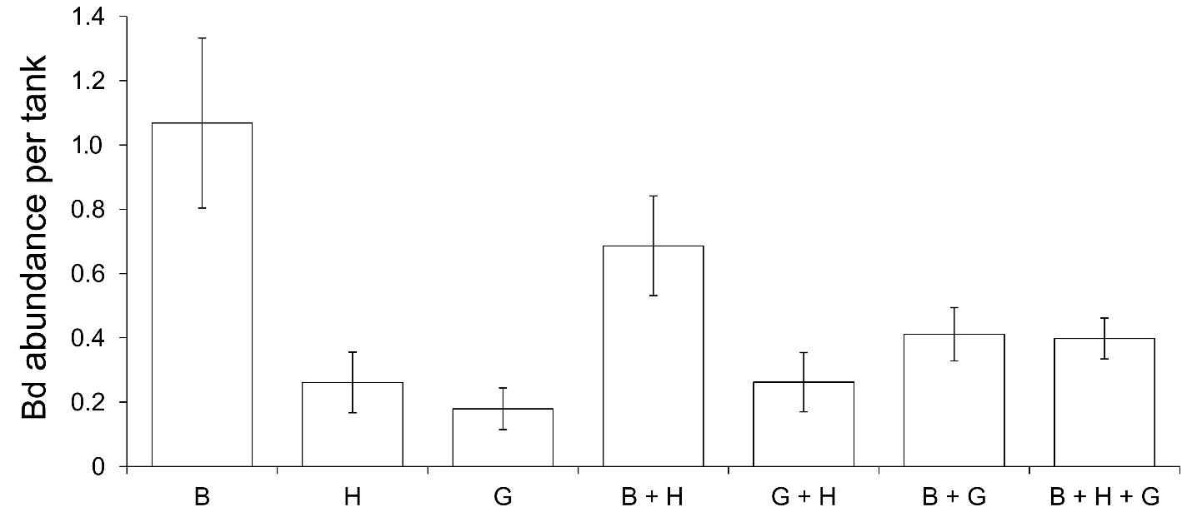
Fig. S1. Average Batrachochytrium dendrobatidis (Bd) prevalence and infection intensity with varying host diversity. Species combinations are labeled on the x-axis and represent the number of individuals of each species (‘B’ for Bufo terrestris, ‘H’ for Hyla cinerea and G for Gastrophryne carolinensis). Values are averaged across low- and high-density treatments and represented as tank means (+SE) because neither density (χ² = 0·220, P = 0·639) nor the interaction between density and diversity (χ² = 0·700,P = 0·403) significantly influenced Bd prevalence or infection intensity.

